VSMS Backend Practical Guide

API Gateway + Lambda + DynamoDB + Offline Synchronization

Module
Visual Screening Management System (VSMS)

Objective
Build a serverless backend for the Visual Screening Management System using:
- Amazon DynamoDB
- AWS Lambda
- Amazon API Gateway
- Amazon CloudWatch
Students will learn how to:
- Create DynamoDB tables
- Develop Lambda functions
- Configure IAM permissions
- Deploy APIs using API Gateway
- Test APIs using Postman
- Monitor Lambda using CloudWatch
- Implement offline synchronization support

Solution Architecture
Postman / React PWA
|
v
API Gateway
|
v
Lambda
|
v
DynamoDB
CloudWatch Logs
^
|
Lambda

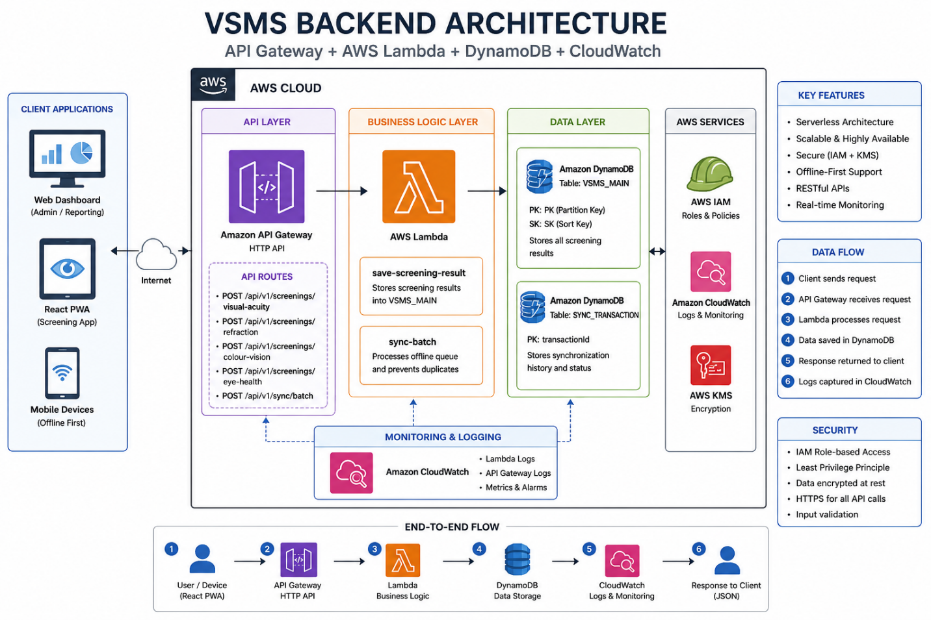

Prerequisites
Students must have:
- AWS Account
- IAM User with AdministratorAccess
- AWS Console Access
- Postman Installed
- Basic JavaScript Knowledge
- Basic REST API Knowledge

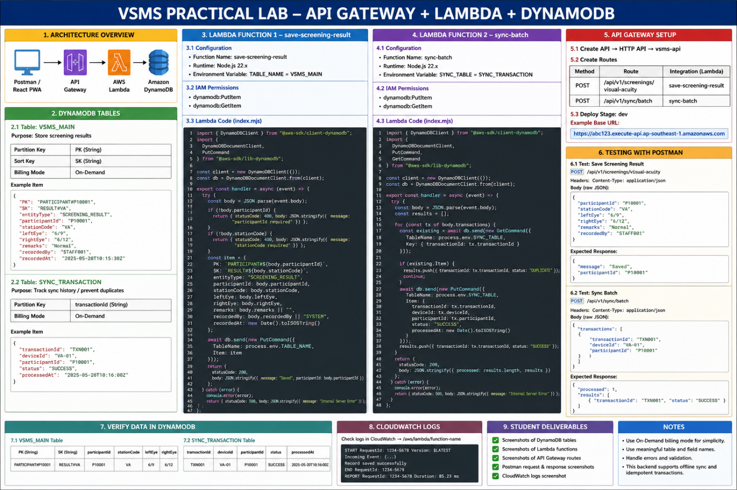

Task 1 – Create DynamoDB Tables

Task Description
Create the DynamoDB tables required by VSMS.

Create VSMS_MAIN
Navigate:
AWS Console
→ DynamoDB
→ Create Table
Configuration:
Property | Value
Table Name | VSMS_MAIN
Partition Key | PK
Sort Key | SK
Billing Mode | On-Demand

Create SYNC_TRANSACTION
Configuration:
Property | Value
Table Name | SYNC_TRANSACTION
Partition Key | transactionId
Billing Mode | On-Demand

Deliverables
- Screenshot of VSMS_MAIN
- Screenshot of SYNC_TRANSACTION

Task 2 – Create Lambda Function

Task Description
Create a Lambda function to save screening results.
Navigate:
AWS Console
→ Lambda
→ Create Function
Configuration:
Property | Value
Function Name | save-screening-result
Runtime | Node.js 22.x
Architecture | x86_64

Deliverables
- Lambda Configuration Screenshot

Task 3 – Configure IAM Permissions
Open:
Lambda
→ Configuration
→ Permissions
→ Execution Role
Add Inline Policy:
{
"Version":"2012-10-17",
"Statement":[
{
"Effect":"Allow",
"Action":[
"dynamodb:GetItem",
"dynamodb:PutItem"
],
"Resource":"*"
}
]
}

Deliverables
- IAM Policy Screenshot

Task 4 – Configure Environment Variables
Navigate:
Lambda
→ Configuration
→ Environment Variables
Add:
TABLE_NAME=VSMS_MAIN

Deliverables
- Environment Variable Screenshot

Task 5 – Deploy save-screening-result Lambda

Task Description
Deploy the Lambda source code.
Create project:
mkdir save-screening-result
cd save-screening-result
Initialize Node.js:
npm init -y
Install dependencies:
npm install @aws-sdk/client-dynamodb
npm install @aws-sdk/lib-dynamodb

package.json
{
"name": "vsms-backend",
"version": "1.0.0",
"type": "module",
"dependencies": {
"@aws-sdk/client-dynamodb": "^3.x",
"@aws-sdk/lib-dynamodb": "^3.x"
}
}

index.mjs
import { DynamoDBClient } from "@aws-sdk/client-dynamodb";
import {
DynamoDBDocumentClient,
PutCommand
} from "@aws-sdk/lib-dynamodb";
const client = new DynamoDBClient({});
const db =
DynamoDBDocumentClient.from(client);
export const handler = async (event) => {
try {
const body =
JSON.parse(event.body);
if (!body.participantId) {
return {
statusCode: 400,
body: JSON.stringify({
message: "participantId required"
})
};
}
const item = {
PK:
`PARTICIPANT#${body.participantId}`,
SK:
`RESULT#${body.stationCode}`,
entityType:
"SCREENING_RESULT",
participantId:
body.participantId,
stationCode:
body.stationCode,
leftEye:
body.leftEye,
rightEye:
body.rightEye,
remarks:
body.remarks || "",
recordedAt:
new Date().toISOString()
};
await db.send(
new PutCommand({
TableName:
process.env.TABLE_NAME,
Item:
item
})
);
return {
statusCode: 200,
body: JSON.stringify({
message: "Saved",
participantId:
body.participantId
})
};
} catch (error) {
console.error(error);
return {
statusCode: 500,
body: JSON.stringify({
message:
"Internal Server Error"
})
};
}
};

Package Lambda
zip -r function.zip .
Upload ZIP to Lambda.
Click Deploy.

Deliverables
- Source Code
- Deployment Screenshot

Task 6 – Test Lambda
Create Test Event:
{
"body":"{
\"participantId\":\"P10001\",
\"stationCode\":\"VA\",
\"leftEye\":\"6/9\",
\"rightEye\":\"6/12\"
}"
}
Expected Response:
{
"message":"Saved",
"participantId":"P10001"
}

Deliverables
- Test Event Screenshot
- Successful Execution Screenshot

Task 7 – Verify DynamoDB
Navigate:
DynamoDB
→ VSMS_MAIN
→ Explore Table
Expected Record:
{
"PK":"PARTICIPANT#P10001",
"SK":"RESULT#VA",
"leftEye":"6/9",
"rightEye":"6/12"
}

Deliverables
- DynamoDB Record Screenshot

Task 8 – Create API Gateway
Navigate:
AWS Console
→ API Gateway
→ Create API
Select:
HTTP API
Name:
vsms-api

Deliverables
- API Gateway Screenshot

Task 9 – Create API Route
Create Route:
POST /api/v1/screenings/visual-acuity

Deliverables
- Route Screenshot

Task 10 – Integrate Lambda
Attach Lambda:
save-screening-result

Deliverables
- Integration Screenshot

Task 11 – Deploy API
Create Stage:
dev
Deploy API.
Example URL:
https://abc123.execute-api.ap-southeast-1.amazonaws.com

Deliverables
- Deployment Screenshot
- API Endpoint Screenshot

Task 12 – Test API Using Postman
Method:
POST
Headers:
Content-Type: application/json
Body:
{
"participantId":"P10001",
"stationCode":"VA",
"leftEye":"6/9",
"rightEye":"6/12"
}
Expected Response:
{
"message":"Saved"
}

Deliverables
- Request Screenshot
- Response Screenshot

Task 13 – Create sync-batch Lambda
Create Lambda:
sync-batch
Add Environment Variable:
SYNC_TABLE=SYNC_TRANSACTION
Purpose:
- Process Offline Queue
- Prevent Duplicate Transactions
- Store Synchronization History

Deliverables
- sync-batch Screenshot
- Environment Variable Screenshot

Task 14 – Verify CloudWatch Logs
Navigate:
Lambda
→ Monitor
→ View Logs
Expected:
START RequestId
Record saved
END RequestId

Deliverables
- CloudWatch Screenshot

Task 15 – Submission Checklist
Students must submit:
- VSMS_MAIN Screenshot
- SYNC_TRANSACTION Screenshot
- Lambda Function Screenshot
- IAM Policy Screenshot
- Environment Variables Screenshot
- Lambda Test Screenshot
- DynamoDB Verification Screenshot
- API Gateway Screenshot
- Route Screenshot
- Lambda Integration Screenshot
- API Deployment Screenshot
- Postman Request Screenshot
- Postman Response Screenshot
- CloudWatch Logs Screenshot

Success Criteria
Students have successfully completed the practical if:
- DynamoDB tables are created
- Lambda function is deployed
- API Gateway route works
- Postman returns HTTP 200
- DynamoDB record is created
- CloudWatch logs are generated

Estimated Duration
90–120 Minutes

